1.Fileutils.copyfile not working – pls see below

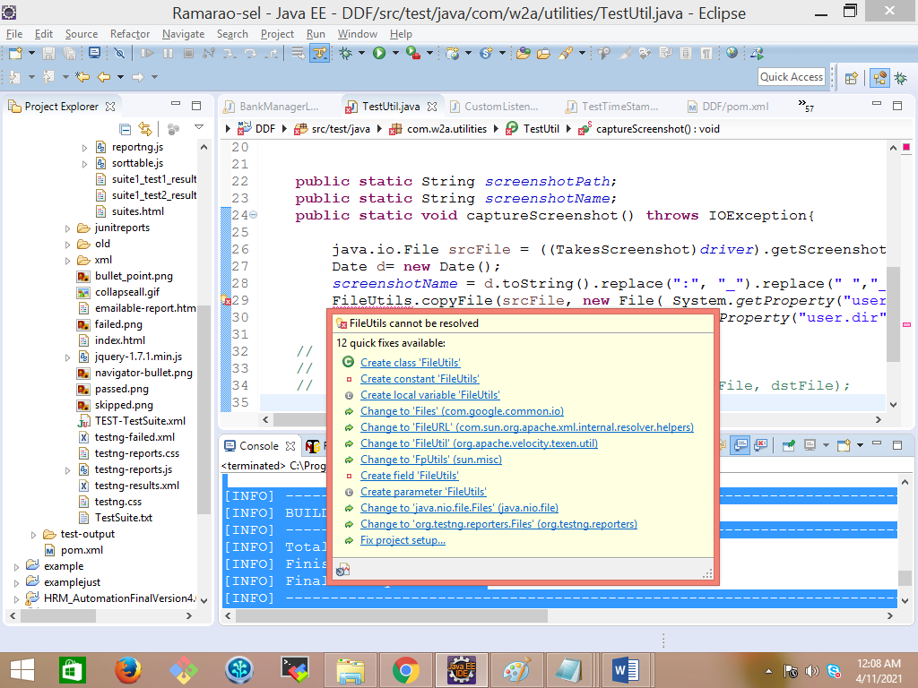

2. Tried FileHandler.copy below:

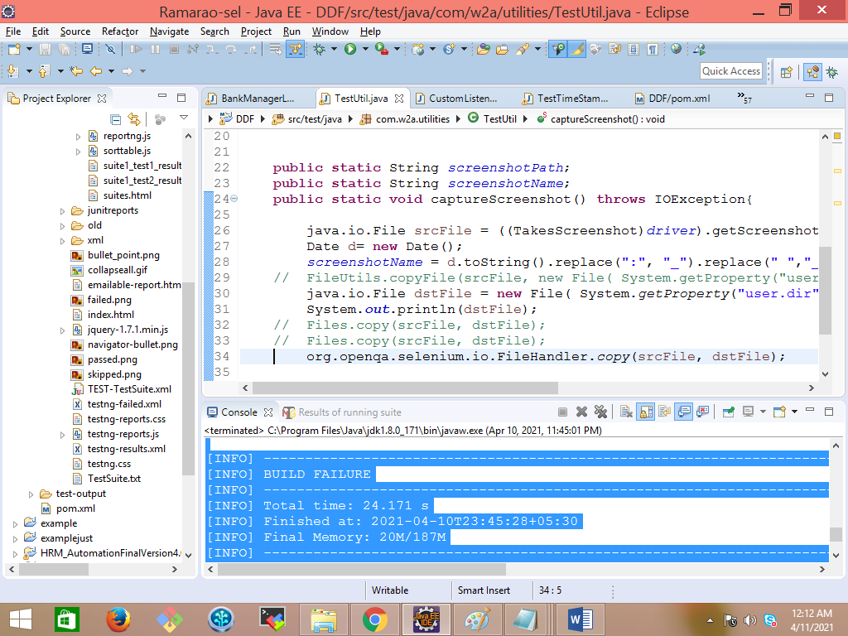

3. CONSOLE DETAILS:- I printed the timestamp file getting generated and exception in yellow

[INFO] Scanning for projects...

[INFO]

[INFO] ------------------------------------------------------------------------

[INFO] Building DDF 0.0.1-SNAPSHOT

[INFO] ------------------------------------------------------------------------

[WARNING] The POM for org.testng:testng:jar:5.14.3 is invalid, transitive dependencies (if any) will not be available, enable debug logging for more details

[WARNING] The POM for org.testng:testng:jar:5.14.4 is invalid, transitive dependencies (if any) will not be available, enable debug logging for more details

[WARNING] The POM for org.testng:testng:jar:5.14.5 is invalid, transitive dependencies (if any) will not be available, enable debug logging for more details

[WARNING] The POM for com.beust:jcommander:jar:1.66 is missing, no dependency information available

[INFO]

[INFO] --- maven-resources-plugin:2.6:resources (default-resources) @ DDF ---

[WARNING] Using platform encoding (Cp1252 actually) to copy filtered resources, i.e. build is platform dependent!

[INFO] skip non existing resourceDirectory E:\Ramarao-sel\DDF\src\main\resources

[INFO]

[INFO] --- maven-compiler-plugin:3.1:compile (default-compile) @ DDF ---

[INFO] No sources to compile

[INFO]

[INFO] --- maven-resources-plugin:2.6:testResources (default-testResources) @ DDF ---

[WARNING] Using platform encoding (Cp1252 actually) to copy filtered resources, i.e. build is platform dependent!

[INFO] Copying 1 resource

[INFO]

[INFO] --- maven-compiler-plugin:3.1:testCompile (default-testCompile) @ DDF ---

[INFO] Changes detected - recompiling the module!

[WARNING] File encoding has not been set, using platform encoding Cp1252, i.e. build is platform dependent!

[INFO] Compiling 13 source files to E:\Ramarao-sel\DDF\target\test-classes

[INFO]

[INFO] --- maven-surefire-plugin:2.18.1:test (default-test) @ DDF ---

[INFO] Surefire report directory: E:\Ramarao-sel\DDF\target\surefire-reports

-------------------------------------------------------

T E S T S

-------------------------------------------------------

Running TestSuite

Starting ChromeDriver 2.35.528161 (5b82f2d2aae0ca24b877009200ced9065a772e73) on port 35017

Only local connections are allowed.

Apr 10, 2021 11:45:17 PM org.openqa.selenium.remote.ProtocolHandshake createSession

INFO: Detected dialect: OSS

E:\Ramarao-sel\DDF\target\surefire-reports\html\Sat_Apr_10_23_45_23_IST_2021.jpg

java.io.FileNotFoundException: E:\Ramarao-sel\DDF\target\surefire-reports\html\Sat_Apr_10_23_45_23_IST_2021.jpg (The system cannot find the path specified)

at java.io.FileOutputStream.open0(Native Method)

at java.io.FileOutputStream.open(FileOutputStream.java:270)

at java.io.FileOutputStream.<init>(FileOutputStream.java:213)

at com.google.common.io.Files$FileByteSink.openStream(Files.java:192)

at com.google.common.io.Files$FileByteSink.openStream(Files.java:180)

at com.google.common.io.ByteSource.copyTo(ByteSource.java:268)

at com.google.common.io.Files.copy(Files.java:319)

at com.w2a.utilities.TestUtil.captureScreenshot(TestUtil.java:32)

at com.w2a.listeners.CustomListeners.onTestFailure(CustomListeners.java:34)

at org.testng.internal.Invoker.runTestListeners(Invoker.java:1731)

at org.testng.internal.Invoker.runTestListeners(Invoker.java:1714)

at org.testng.internal.Invoker.invokeMethod(Invoker.java:714)

at org.testng.internal.Invoker.invokeTestMethod(Invoker.java:869)

at org.testng.internal.Invoker.invokeTestMethods(Invoker.java:1193)

at org.testng.internal.TestMethodWorker.invokeTestMethods(TestMethodWorker.java:126)

at org.testng.internal.TestMethodWorker.run(TestMethodWorker.java:109)

at org.testng.TestRunner.privateRun(TestRunner.java:744)

at org.testng.TestRunner.run(TestRunner.java:602)

at org.testng.SuiteRunner.runTest(SuiteRunner.java:380)

at org.testng.SuiteRunner.runSequentially(SuiteRunner.java:375)

at org.testng.SuiteRunner.privateRun(SuiteRunner.java:340)

at org.testng.SuiteRunner.run(SuiteRunner.java:289)

at org.testng.SuiteRunnerWorker.runSuite(SuiteRunnerWorker.java:52)

at org.testng.SuiteRunnerWorker.run(SuiteRunnerWorker.java:86)

at org.testng.TestNG.runSuitesSequentially(TestNG.java:1301)

at org.testng.TestNG.runSuitesLocally(TestNG.java:1226)

at org.testng.TestNG.runSuites(TestNG.java:1144)

at org.testng.TestNG.run(TestNG.java:1115)

at org.apache.maven.surefire.testng.TestNGExecutor.run(TestNGExecutor.java:295)

at org.apache.maven.surefire.testng.TestNGXmlTestSuite.execute(TestNGXmlTestSuite.java:84)

at org.apache.maven.surefire.testng.TestNGProvider.invoke(TestNGProvider.java:90)

at org.apache.maven.surefire.booter.ForkedBooter.invokeProviderInSameClassLoader(ForkedBooter.java:203)

at org.apache.maven.surefire.booter.ForkedBooter.runSuitesInProcess(ForkedBooter.java:155)

at org.apache.maven.surefire.booter.ForkedBooter.main(ForkedBooter.java:103)

2

4

E:\Ramarao-sel\DDF\target\surefire-reports\html\Sat_Apr_10_23_45_27_IST_2021.jpg

java.io.FileNotFoundException: E:\Ramarao-sel\DDF\target\surefire-reports\html\Sat_Apr_10_23_45_27_IST_2021.jpg (The system cannot find the path specified)

at java.io.FileOutputStream.open0(Native Method)

at java.io.FileOutputStream.open(FileOutputStream.java:270)

at java.io.FileOutputStream.<init>(FileOutputStream.java:213)

at com.google.common.io.Files$FileByteSink.openStream(Files.java:192)

at com.google.common.io.Files$FileByteSink.openStream(Files.java:180)

at com.google.common.io.ByteSource.copyTo(ByteSource.java:268)

at com.google.common.io.Files.copy(Files.java:319)

at com.w2a.utilities.TestUtil.captureScreenshot(TestUtil.java:32)

at com.w2a.listeners.CustomListeners.onTestFailure(CustomListeners.java:34)

at org.testng.internal.Invoker.runTestListeners(Invoker.java:1731)

at org.testng.internal.Invoker.runTestListeners(Invoker.java:1714)

at org.testng.internal.Invoker.invokeMethod(Invoker.java:714)

at org.testng.internal.Invoker.invokeTestMethod(Invoker.java:869)

at org.testng.internal.Invoker.invokeTestMethods(Invoker.java:1193)

at org.testng.internal.TestMethodWorker.invokeTestMethods(TestMethodWorker.java:126)

at org.testng.internal.TestMethodWorker.run(TestMethodWorker.java:109)

at org.testng.TestRunner.privateRun(TestRunner.java:744)

at org.testng.TestRunner.run(TestRunner.java:602)

at org.testng.SuiteRunner.runTest(SuiteRunner.java:380)

at org.testng.SuiteRunner.runSequentially(SuiteRunner.java:375)

at org.testng.SuiteRunner.privateRun(SuiteRunner.java:340)

at org.testng.SuiteRunner.run(SuiteRunner.java:289)

at org.testng.SuiteRunnerWorker.runSuite(SuiteRunnerWorker.java:52)

at org.testng.SuiteRunnerWorker.run(SuiteRunnerWorker.java:86)

at org.testng.TestNG.runSuitesSequentially(TestNG.java:1301)

at org.testng.TestNG.runSuitesLocally(TestNG.java:1226)

at org.testng.TestNG.runSuites(TestNG.java:1144)

at org.testng.TestNG.run(TestNG.java:1115)

at org.apache.maven.surefire.testng.TestNGExecutor.run(TestNGExecutor.java:295)

at org.apache.maven.surefire.testng.TestNGXmlTestSuite.execute(TestNGXmlTestSuite.java:84)

at org.apache.maven.surefire.testng.TestNGProvider.invoke(TestNGProvider.java:90)

at org.apache.maven.surefire.booter.ForkedBooter.invokeProviderInSameClassLoader(ForkedBooter.java:203)

at org.apache.maven.surefire.booter.ForkedBooter.runSuitesInProcess(ForkedBooter.java:155)

at org.apache.maven.surefire.booter.ForkedBooter.main(ForkedBooter.java:103)

Tests run: 2, Failures: 2, Errors: 0, Skipped: 0, Time elapsed: 15.981 sec <<< FAILURE! - in TestSuite

loginAsBankManager(com.w2atestcases.BankManagerLoginTest) Time elapsed: 3.159 sec <<< FAILURE!

java.lang.AssertionError: Login not successful

at org.testng.Assert.fail(Assert.java:93)

at com.w2atestcases.BankManagerLoginTest.loginAsBankManager(BankManagerLoginTest.java:25)

addCustomer(com.w2atestcases.AddCustomerTest) Time elapsed: 3.546 sec <<< FAILURE!

java.lang.AssertionError: Add customer not successful

at org.testng.Assert.fail(Assert.java:93)

at com.w2atestcases.AddCustomerTest.addCustomer(AddCustomerTest.java:39)

Results :

Failed tests:

AddCustomerTest.addCustomer:39 Add customer not successful

BankManagerLoginTest.loginAsBankManager:25 Login not successful

Tests run: 2, Failures: 2, Errors: 0, Skipped: 0

[INFO] ------------------------------------------------------------------------

[INFO] BUILD FAILURE

[INFO] ------------------------------------------------------------------------

[INFO] Total time: 24.171 s

[INFO] Finished at: 2021-04-10T23:45:28+05:30

[INFO] Final Memory: 20M/187M

[INFO] ------------------------------------------------------------------------

[ERROR] Failed to execute goal org.apache.maven.plugins:maven-surefire-plugin:2.18.1:test (default-test) on project DDF: There are test failures.

[ERROR]

[ERROR] Please refer to E:\Ramarao-sel\DDF\target\surefire-reports for the individual test results.

[ERROR] -> [Help 1]

[ERROR]

[ERROR] To see the full stack trace of the errors, re-run Maven with the -e switch.

[ERROR] Re-run Maven using the -X switch to enable full debug logging.

[ERROR]

[ERROR] For more information about the errors and possible solutions, please read the following articles:

[ERROR] [Help 1] http://cwiki.apache.org/confluence/display/MAVEN/MojoFailureException

4.Target folder – files not added

